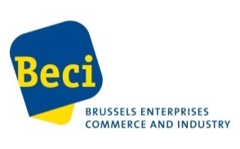
Registration form - Business to business meetings with Egyptian companies

Monday 17 June 2019 - 14.00 – 16.00

Venue: Hôtel Le Châtelain, Rue du Châtelain 17, B-1000 Bruxelles

First name, Name : ..............................................................

Company : ......................................................................

Address : ........................................................................

TEL.: ........................................................................

E-Mail : ........................................................................

WebSite : .........................................................................

Sector of activity : .............................................................

- I would like to meet the following company(ies) :

- Foreign Trade Association
- Business Arab Consultants
- Misron
- Gawish Import & Export Co
- El Sondoss Co. For Wood products and Manufacturing
- Bayt El Khebra Tax Consultancy
- Free Trade
- Sirgany Jewels Group
- Pharma Art
- Flex- Trade
- Three Brothers for Hotel Supplies
- Egyptian French Co. for hotel Management (Egyfrance)
- Nile Vet
- Top Vision
- Abou Aly Trade
- Remal Mining Co.
- B.Chem Consultants & Agents
- El Gezirah Farms & nurseries
- Samoral
- United salt Egypt
Please send the form before 13th June to: jpm@beci.be
Information: J.-Ph. Mergen – Director Internationalisation Enterprise Europe Brussels – BECI – Tel : 02 210 01 77 – E-mail : jpm@beci.be

